Chapter 5 Electrical physics

Chapter Test Total marks 45

Name: Class: Date:

Section A (1 mark per question)

Question 1

The lower slot of any power point in your home will enable a connection to:

1. the active part of the supply circuit
2. the neutral part of the supply circuit
3. the earth wiring in your home
4. a fuse

Question 2

Which of the following lists the factors that affect the resistance of a conductor?

1. Length, lustre and temperature
2. Temperature, density and length
3. Length, diameter and lustre
4. Diameter, length and temperature

Question 3

Which of the following is the correct definition for electrical current?

1. The charge per unit volume per unit time
2. The charge per unit volume
3. The charge per unit time
4. The time per unit charge

Question 4

How does the total resistance of two identical resistors in parallel (*R*tot) compare to the resistance of the individual resistors (*R*)?

1. *R*tot = *R*
2. *R*tot < *R*
3. *R*tot > *R*
4. It depends on the resistance, *R*.

Question 5

How much current is drawn by a 6.0 W torch globe that utilises two 1.5 V batteries placed in series?

1. 0.5 A
2. 4.0 A
3. 9.0 A
4. 2.0 A

Section B

Question 1

A negative charge lies within a uniform electric field of strength 5 × 10-4 NC-1 directed up the page. The charge on an electron is −1.602 × 10-19 C.

**a.** Calculate the size of the force acting on the particle. (3 marks)

**b.** Describe the effect of the force on the particle. (2 marks)

Question 2

Describe the energy transformations that occur during the operation of the circuit shown below when the switch is closed. (3 marks)

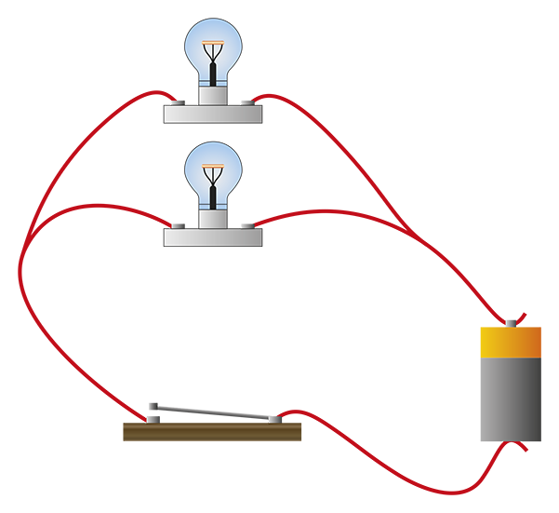

Question 3

A battery in a circuit has current of 4.5 A passing through it.

**a.** How many coulombs of charge pass through the battery in 5 seconds? (1 mark)

**b.** If the battery provides a potential difference of 9.0 V, how many joules of energy does it provide to the circuit each second? (2 marks)

Question 4

**a.** How much energy, in kilowatt hours and joules, will a 200 W globe use in   
4 hours of operation? (2 marks)

**b.** An electricity company charges 60 cents per kilowatt hour (kW h) of electricity consumed. How much does it cost to use this 200 W globe for one hour? (2 marks)

Question 5

**a.** Samantha discovers that the 12 V battery in her new car is connected via a switch to   
two heater elements (resistors) in parallel, which are used to heat the driver and   
passenger seats. Draw a labelled diagram to represent this circuit. (3 marks)

**b.** Thinking that the seats are not heating properly Samantha decides to use a voltmeter to   
check the operation of the switch. Draw how she would attach the voltmeter to the   
circuit in part a. (2 marks)

**c.** When the switch is open, what value should the voltmeter read? (1 mark)

**d.** When the switch is closed, what value should the voltmeter read? (1 mark)

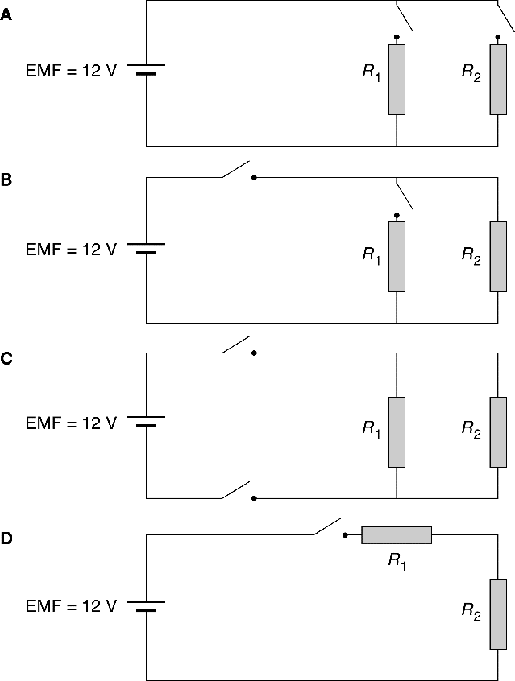**e.** Samantha takes her car to an auto electrician who rewires the seat heating circuit to allow each seat to be individually heated. Select the correct circuit from those shown below. (1 mark)

**f.** The resistors are identical and are rated at 300 Ω. What is the total resistance of the   
circuit when both seats are heated at the same time? (2 marks)

**g.** What current is drawn at this time? (1 mark)

**h.** If this amount of current were to go through a person it would cause serious injury.   
Does this mean that the seat warmer elements are potentially dangerous? (1 mark)

Question 6

Two electrical devices have current–voltage characteristics as shown below.

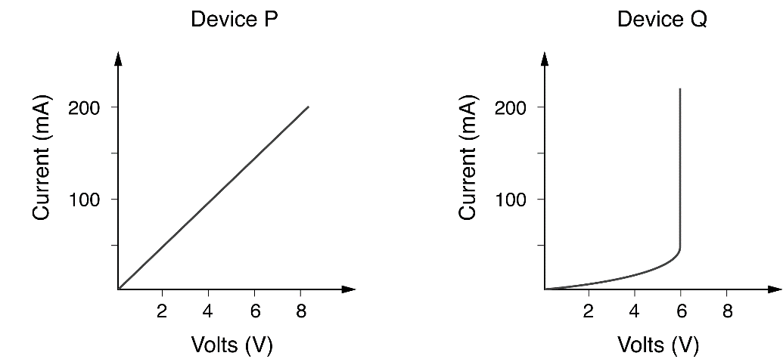

**a.** Which of the two components obeys Ohm’s law? (1 mark)

**b.** Determine the resistance of this device. (2 marks)

**c.** What is the effective resistance of the other device when a current of 200 mA flows   
through it? Why is this not a useful quantity? (2 marks)

Question 7

The two components in Question 4 are now connected in a series circuit as shown in the following diagram. The battery has zero internal resistance and the current at point K is 100 mA.

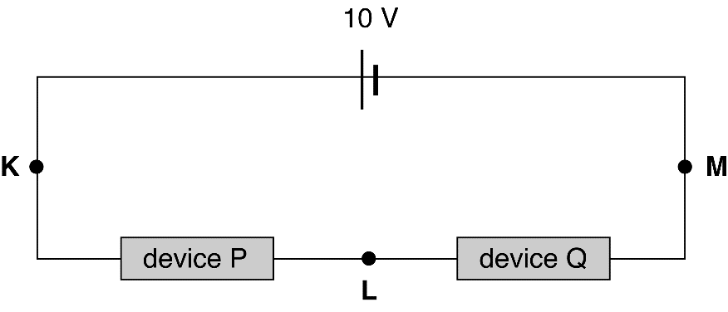

**a.** What is the current at point L? (2 marks)

**b.** Calculate the potential difference between points K and L. (2 marks)

**c.** Calculate the potential difference between points L and M. (2 marks)

**d.** What is the effective resistance of device Q in this situation? (2 marks)